Second Grade - Session 7
Introduction
Engage with the student. Ask: How is your day going? Have you been on any field trips this year? Where did you go? Does your class have any scheduled? Where are you going?

Warm Up
Note: If a letter is written between the backslash symbol it means to say the sound
Example: /s/ means to make the sound sssss as in snake.

Mentor says: Let’s play a word game. Today, I am going to say some words and I would like for you to tell me the first sound you hear in the word.
Let’s try one together. The word is “sun”. What is the first sound you hear in the word “sun”?
Mentee says: /s/ Mentor says: That’s correct, /s/ is the first sound you hear in the word “sun”!
(If the mentee says the incorrect sound, gently correct him or her. Say: Let’s try that one again, listen carefully for the first or beginning sound in the word.) Let’s try a few more!

log - /l/ teacher - /t/ gate - /g/ sand - /s/
popcorn - /p/ key - /k/ monkey - /m/ van - /v/
find - /f/ harp - /h/ water - /w/ lion - /l/

Leveled Reading Lesson
Focus: Using More than One Reading Strategy at a Time

Materials: students reading books (usually in a baggie or bin), journal, pencil, sticky notes, glue stick and reading log

Genre: Fiction or Nonfiction

Before Reading
- Mentor says: Last time we met, we talked about strategies to use when you come to a tricky word in your book. Today, I want to teach you that readers may use TWO strategies at the same time when they are trying to figure out a tricky word. Often times, it helps to read the sentence and think about what word would go in that spot. Then, say the first part of the word to check yourself.
- Mentor says: Let’s try one!
- (See attached document for this demonstration activity) Mentor says: Watch how I solve this tricky word. I need to do two things at once. First, I’ll reread the sentence and think about what would make sense. Second, I’ll double check my guess by saying the the first part of the word and then, I’ll put the two things together. Ready? Here is the word “atmosphere” and here is the sentence. Earth’s atmosphere is made up of four layers. (show the student the sentence)
- Mentor says: First, I am rereading and thinking about what might make sense, Earth’s….. something or other…. is made up of four layers. Hmmm, It’s got to be something that is a part of the earth, maybe the earth’s crust or the earth’s air. Now, I am going to say the beginning part of the word and check it. (Point to the first part of the word and say “at”.) Now, I’ll read the whole thing and see if the word will just pop right out of my mouth. Earth’s atmosphere! Yes! That’s it, atmosphere! Let’s read the entire sentence again with the tricky word in it: Earth’s atmosphere is made up of four layers!
During Reading
- Mentor says: So as we are reading today, I would like for you to try this strategy when you come to a tricky word. Let’s get out our books and I would like for you to start with the book that you think is the most difficult to read.
- Help the student try out this new strategy when they come to an tricky word.
After Reading
- Mentor says: Remember, when you are reading and you come to a tricky word, you can try using two strategies at the same time.
- Have student glue the “Using Two Strategies” sheet into their journal.

Text-Dependent Questions:

- Ask one or both of the following questions.
- Align the question to the book you just read.
- Discuss the answer and if possible, ask student to show the place where they found the answer in the text.

Fiction: What effect do the events in the story have on the characters?
Nonfiction: How can you help yourself understand what _______(tricky words in the book) means?

Active Reading Lesson
The volunteer will read to the student during this portion of the session. The student will choose and bring a book to the session which will be read several times. Each reading has a specific focus. Refer to your active reading lesson note cards or lessons to guide you through each read. Today, you will start with: 2nd read and focus on that specific goal.

1st Read - Goal: Understanding the Gist of the Story
2nd Read - Goal: Studying the Events in the Story
3rd Read - Goal: Getting to Know the Characters in the Story
4th Read - Goal: Connecting with the Story

Wrap Up
Mentor says: “Thank you for working with me today! I enjoyed our time together and I am proud of your work. I will return to work with you next day of the week to work with you.”

Please remember the following:
- Fill out the teacher/mentor communication log
- Check the school calendar for upcoming events
- Check your personal calendar to determine scheduling conflicts. Remember, students are eagerly awaiting your arrival and their mentoring time with you.
If you have any questions or concern, please share them with a school employee (teacher, counselor, assistant principal or principal, etc.) before leaving the building.

Sometimes we have to use two strategies at the same time!

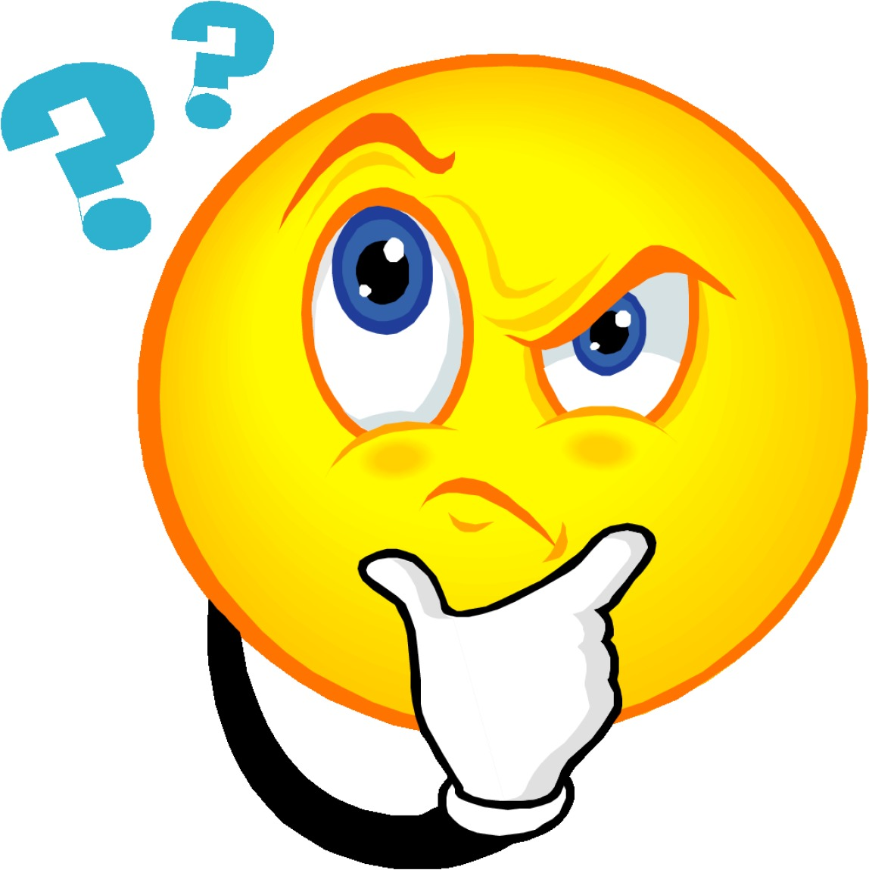
Think about what would make sense in the sentence!

AND

Say the first part of the word!

Example: Earth’s atmosphere is made up of four layers.

