Second Grade - Session 9
Introduction
Engage with the student. Ask: How is your day going? What have you been learning about in science class lately?
Warm Up
Note: If a letter is written between the backslash symbols it means to say the sound
Example: /s/ means to make the sound ssss as in snake.

Mentor says:
Let’s play a word game. Today, I am going to say some words and I would like for you to tell me the last sound you hear in the word.
Let’s try one together. The word is “man”. What is the last sound you hear in the word “man”?
Mentee says: /n/ Mentor says: That’s correct, /n/ is the last sound you hear in the word “man”! (If the mentee says the incorrect sound, gently correct him or her. Say: Let’s try that one again, listen carefully for the last or ending sound in the word.) Let’s try a few more!

river - /r/ trip - /p/ flag - /g/ goat - /t/
spoon - /n/ yell - /l/ mom - /m/ storm - /m/
friend - /d/ book - /k/ lemon - /n/ past - /t/

Leveled Reading Lesson
Focus: Readers Pay Close Attention to Details
Materials: students reading books (usually in a baggie or bin), journal, pencil, sticky notes, glue stick and reading log

Genre: Nonfiction

Note: Make sure your student has nonfiction books in their bin/baggie.

Before Reading:
- Mentor Says: So, as you begin reading nonfiction books, I want to teach you that good readers pay close attention to the details and they think, How can I put together what I am seeing in the book, to grow my knowledge of this topic?
- Mentor says: Paying close attention to the details doesn’t only mean the details in the words but also the details in the pictures.
- Mentor says: Let’s try one! Take a look at this image of a pirate ship. (see attached)
What do you already know about pirate ships? (have the student share what they know.)
- Mentor says: Pay close attention to the picture and labels of the pirate ship. What do you notice?
- The student may say things like: “I notice there are many sails.” or “Some sails look like they are used to help steer the ship and others are used to catch the wind.” or “I noticed the walls of the ship are tall and the spaces where the cannons come out of the side of the ship are small.
- Mentor says: So after looking at the details of the diagram, how can I put together what I am seeing, with what I know, to grow my knowledge of the topic?” Allow the student to answer: They may say something like, “the ship provides protection for those on board” or “the ship has many sails which are used for many purposes.”
- Have students write a sentence to describe their new knowledge of the topic. (see attached document)
*Be sure to keep the diagram of the pirate ship as it will also be used in the next lesson.
During Reading
- Mentor says: Today as we read together, let’s pay close attention to the details in the book and think about how they help us grow our knowledge.
- Mentor says: Take out your books and decide which one you want to read first today.
- As the student reads aloud to you, stop to look closely at the pictures and pay close attention to the details. Discuss how this information can help grow your knowledge on the topic.
After Reading
- Have the student write in their journal one example of how they studied the details in the text and grew their knowledge of the topic.
- Have students glue the pirate ship diagram into their journal to help them remember today’s lesson.

Text-Dependent Questions:

- Ask one or both of the following questions.
- Align the question to the book you just read.
- Discuss the answer and if possible, ask student to show the place where they found the answer in the text.

Nonfiction:
- What is the main idea of this paragraph? How does it connect with what you just read?
- How does the diagram/image (picture/photograph) help you understand what you are reading?

Active Reading Lesson

The volunteer will read to the student during this portion of the session. The student will choose and bring a book to the session which will be read several times. Each reading has a specific focus. Refer to your active reading lesson note cards or lessons to guide you through each read. Today, you will start with: 4th read and focus on that specific goal.

1st Read - Goal: Understanding the Gist of the Story
2nd Read - Goal: Studying the Events in the Story
3rd Read - Goal: Getting to Know the Characters in the Story
4th Read - Goal: Connecting with the Story

Wrap Up
Mentor Says: Thank you for working with me today! I enjoyed our time together and I am proud of your work. I will return to work with you next day of the week to work with you.

Please remember the following:
- Fill out the teacher/mentor communication log
- Check the school calendar for upcoming events
- Check your personal calendar to determine scheduling conflicts. Remember, students are eagerly awaiting your arrival and their mentoring time with you.
- If you have any questions or concern, please share them with a school employee (teacher, counselor, assistant principal or principal, etc.) before leaving the building.

Pay close attention to the details and think about how the information can help grow your knowledge of the topic.
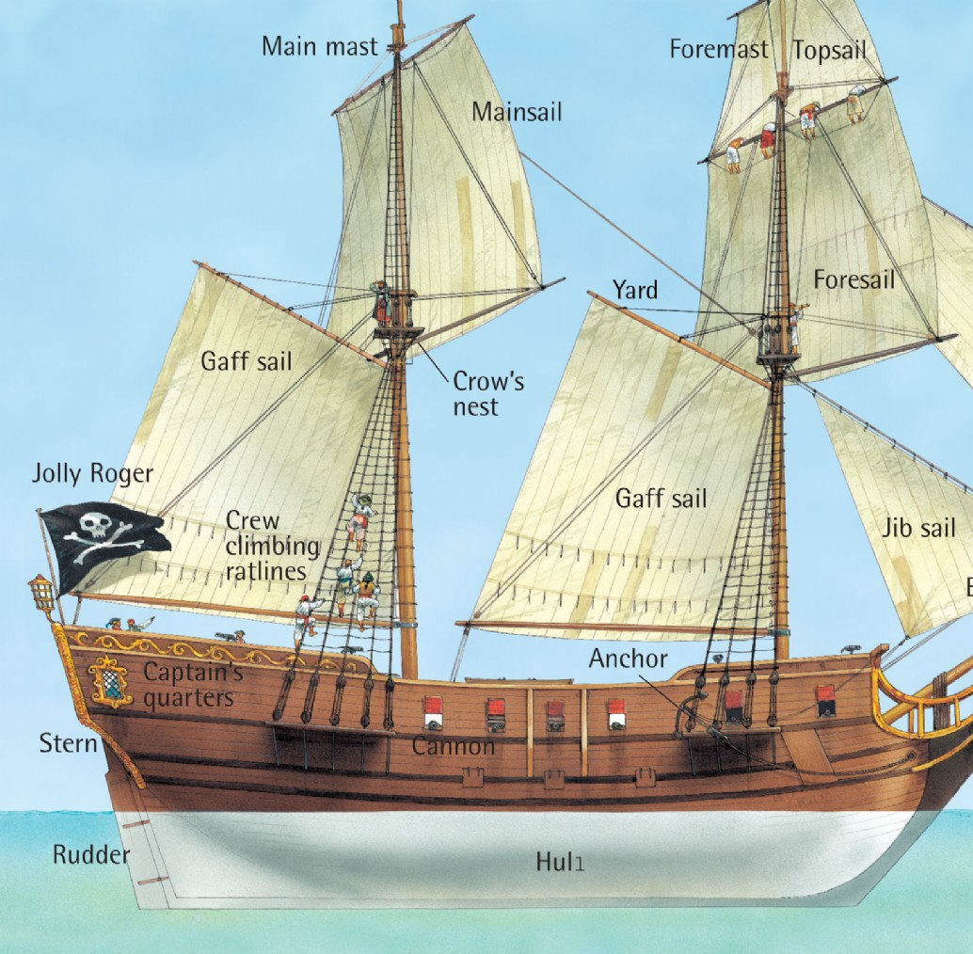

My new knowledge _____________________________________________________________________

