Second Grade - Session 15
Introduction
Engage with the student. Ask: How is your day going? What’s your favorite TV show? Can you tell me about it?
Warm Up
Identifying the short “o” and long “o” sound
A few notes for this lesson.
- If you see a letter written this way /o/ it means to say the sound of the letter
- /ŏ/ means the short o sound as in ox
- /ō/ means the long o sound as in oatmeal

Mentor says: I am going to read some words aloud. I would like for you to listen for the short o sound (sound you hear at the beginning of the word ox) and the long o sound (sound you hear at the beginning of the word oatmeal).
Mentor says: You are going to point to the long o and say /ō/ or point to the short o and say /ŏ/. (see attached document)

octopus - /ŏ/ stop - /ŏ/ moat - /ō/ oak - /ō/
oxen - /ŏ/ ocean - /ō/ throat - /ō/ open - /ō/
mop - /ŏ/ woke - /ō/ smoke - /ō/ top - /ŏ/

Leveled Reading Lesson
Focus: Using Text Features to Learn more about our Books

Materials: students reading books (usually in a baggie or bin), journal, pencil, sticky notes, glue stick and reading log

Genre: Nonfiction

Before Reading:
- Mentor says: Last week, we talked about the importance of thinking about keywords (content specific vocabulary) as you begin reading a new nonfiction book. Today, I want to teach you that besides being able to read the keywords, you must also be able to figure out what those keywords mean. Sometimes you can figure out what the keywords mean by reading the bold print, the text boxes, the labels, and by using the glossary.
During Reading:
- Mentor says: Let’s take a look at the attached examples.
- Discuss each of the four ways to learn the meanings of keywords (bold print, textboxes, labels and glossaries) Ask: Have you ever seen anything like this in your books? Have you ever used bold print, text boxes, labels and glossaries to determine the meaning of words?
- Mentor says: Let’s take a look at the books in your book bag/bin and see if we can find any of these features in your books.
- As you discover these features in the books, discuss how they can help the readers learn the meanings of keywords.
After Reading:
- Mentor says: Remember, as you read nonfiction books, be sure to read and study the bold print, textboxes, labels, and glossaries to learn more about the keywords in the text.
- Have the student glue the attached examples into their journal.

Text-Dependent Questions:

- Ask one or both of the following questions.
- Align the question to the book you just read.
- Discuss the answer and if possible, ask student to show the place where they found the answer in the text.

Nonfiction:
- Identify three text features. Explain the information you learned from each text feature.
- What additional information does the diagram/image provide? How does that support your understanding of the content/topic?

Active Reading Lesson

The volunteer will read to the student during this portion of the session. The student will choose and bring a book to the session which will be read several times. Each reading has a specific focus. Refer to your active reading lesson note cards or lessons to guide you through each read. Today, you will continue with: 2nd read and focus on that specific goal.

1st Read - Goal: Understanding the Gist of the Story
2nd Read - Goal: Studying the Events in the Story
3rd Read - Goal: Getting to Know the Characters in the Story
4th Read - Goal: Connecting with the Story

Wrap Up
Thank you for working with me today! I enjoyed our time together and I am proud of your work. I will return to work with you next day of the week to work with you.

Please remember the following:
- Fill out the teacher/mentor communication log
- Check the school calendar for upcoming events
- Check your personal calendar to determine scheduling conflicts. Remember, students are eagerly awaiting your arrival and their mentoring time with you.
- If you have any questions or concern, please share them with a school employee (teacher, counselor, assistant principal or principal, etc.) before leaving the building.

Learning about keywords from:

Boldface words
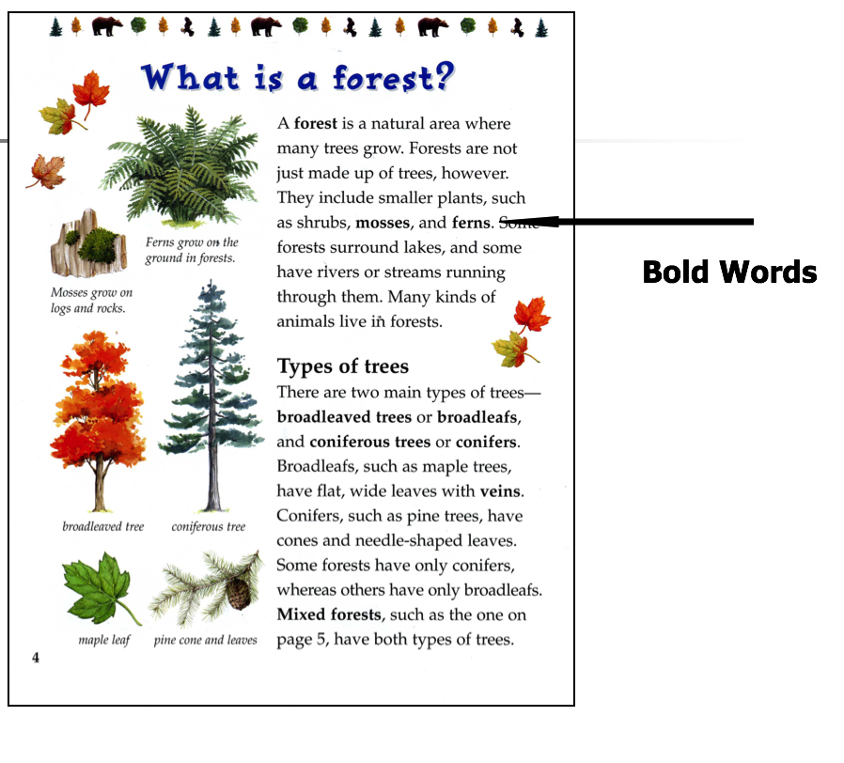
Text Boxes

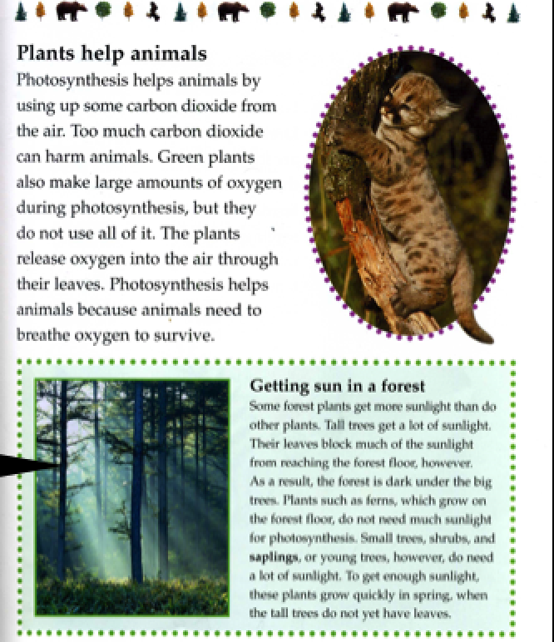Text Box

Labels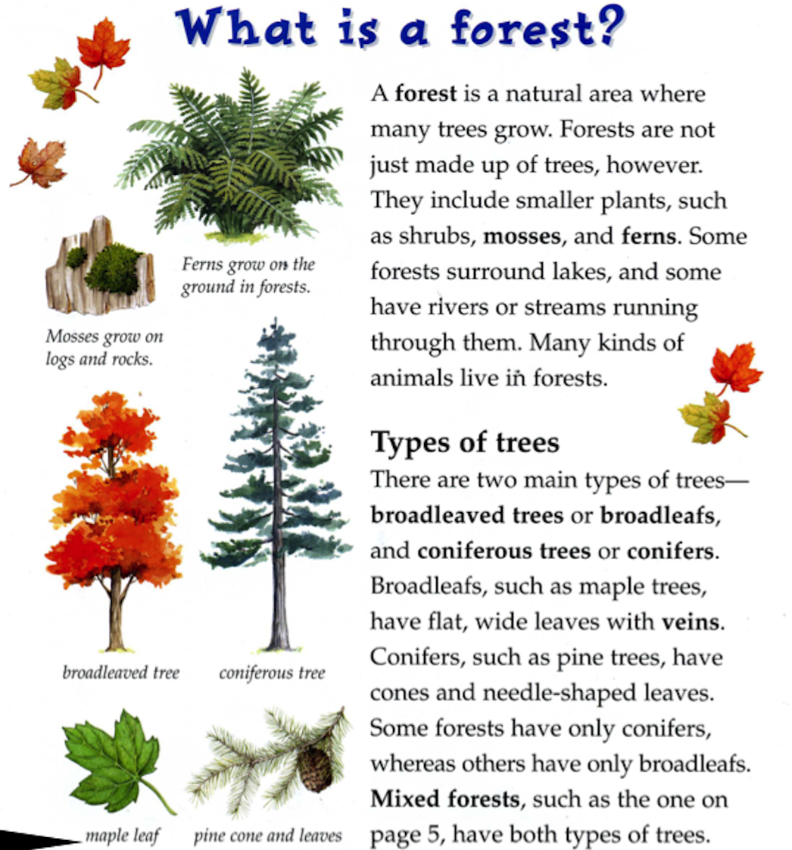

Glossary
