Grade: Six | Session Twenty-Five
Materials Needed: composition notebook for each scholar and mentor, two pocket folder for each scholar, picture of Narcissus by Caravaggio to project, copies of “Narcissus and Echo” for each scholar, mentor toolbox | Focus: One Topic; Different Texts: Reviewing skills using a variety of genres connected to the same text.

Lesson Title: Oh, How I LOVE Me, Me, and Me!

Before the Lesson:

Step One: Write Into the Lesson: To start each session together, we are going to engage in a quickwrite. This means that I will set the timer for 3 minutes and you will write whatever comes to mind about the topic (which will also be a quote connected to our SHINING star theme)for the entire three minutes. It is important that you challenge yourself to write for the entire time! I will write along with you! Here’s today’s quote:

“Even the sun is jealous of the way you shine!”

(It might be necessary for you to explain the quote to the scholar. It is important that you make sure that he/she knows what the quote is about. By doing so, it will allow the scholar to write about the quote with ease.) Set the timer for 3 minutes and allow the scholar time to talk. It might be a challenge for the scholar to write for the entire time. Gently encourage him or her to “keep thinking and keep writing”. It is highly recommended that you write along with the scholar. He/she needs to see you engage in this process as well.)

O.k, scholar. Let’s hear what you have to say about today’s quote. (Allow scholar time to read his/her response.)

Step Two: See, Think, Wonder: I am now going to show you a picture that is going to introduce to you the topic that our new set of lessons will be centered around. When I show you the picture, I want you to first just tell me everything you see. Only focus on what you SEE in the picture, nothing else. (Show scholar(s) the picture. Allow them to share with you what they notice in the picture. Don’t allow them to make inferences just yet. Only note what is seen in the picture.) Great job! Now, I want you to tell me what you think is going on in the picture. This is your time to make some inferences based on what you see in the picture. (Allow time for scholar(s) to share.) Great. Now, I want you to tell me what this picture makes you wonder about. Start all of your statements with “I wonder……..” (Allow time for scholar(s) to share.) Good. Now, do you have any idea what the topic of our new set of lessons will be?

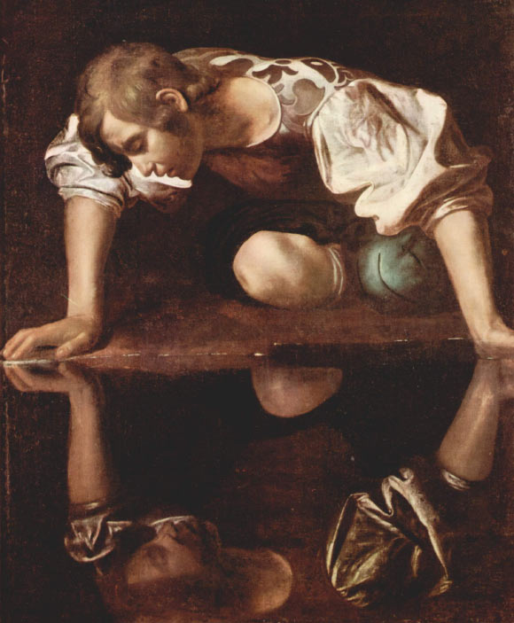

Step Three:: Vocabulary Concept Map:: Last week, we wrapped up a series of lessons all about one topic. This week we will start a new set of lessons all centered around a new topic---NARCISSISM. Do you have any idea what this word means? Let’s take a deeper look at this word by completing a vocabulary concept map. (Pass out vocabulary concept map.) You are already familiar with this as we completed one before for the word LABELS. I am going to share the definition of NARCISSISM with you. (Definition: excessive interest in oneself and one’s physical appearance.) Now, let’s brainstorm some synonyms and antonyms of the word. (Help scholar(s) brainstorm synonyms and antonyms.) Great! Now, let’s think of some real life examples of the word and a picture that we could draw to represent the word. (Help scholar(s) brainstorms examples and a picture he/she could draw.) Hopefully you now have a better understanding of the word NARCISSISM. Understanding this word will help you as we read the different texts about this topic..

Step Three: “Narcissus and Echo”: The first text that we will read is a myth called, “Narcissus and Echo”. What do you know about myths? Based on the title, what might this myth be about? (Allow scholars time to make predictions.) Great! As you read the myth today, I want you to annotate the text. Remember, whenever we read a long text, we chunk the text so that we don’t get lost while reading. After each chunk, we write in the margin. Here are some things to think about while reading. These prompts will help you think of something to write in the margins:

- what you understand right now (what’s happening, who’s who)
- personal experiences that you are reminded of
- visual or sensory images you are experiencing while you read
- questions or wonderings that pop into your head
- predictions about what might happen next
- parts that seem especially important, interesting

(Allow scholar(s) time to read the myth independently. Be sure that the scholar(s) are stopping after each chunk in order to write in the margin. Have a discussion about the myth. You could use these prompts to open the discussion:
- So, what happened in the myth?
- What were some personal experiences that the myth made you think of?
- Were you able to visualize anything as you read?
- What questions or wonderings popped into your head as you were reading?
- What parts did you think were especially important or interesting?

Step Four: Theme Statement: What is the message, the moral, the theme of the myth. Come up with a one-sentence statement of the myth’s theme. It must be supported by details in the text. Discuss.

Closure: I’ve enjoyed our time together and I’m already looking forward to next week! You did an amazing job today. (Please give specific feedback at this point.) Possible feedback starters: I liked the way you_________. or I was impressed when you___________. What comments or questions do you have for me? Answer the questions, if you are able and/or willing to do so. End the session with a handshake and the comment, “continue to be a SHINING star today!”

(Scholars should keep all handouts referenced today in their two pocket folder.)
After Session: Before you leave please fill out the Teacher/Mentor Communication Log, check the school calendar for potential conflicting and upcoming events, check your personal calendar to make sure you will be able to return when you told the scholar you would, as the scholar will be looking forward to seeing you, and share any questions or concerns with a school employee—teacher, counselor, principal, etc.—before leaving the building. Thank you for sharing your time and talent!

