Grade: Six | Session Twenty-Six
Materials Needed: composition notebook for each scholar and mentor, two pocket folder for each scholar, copies of the lyrics, “Selfies” by Nina Nesbitt, copies of a Venn diagram , mentor toolbox | Focus:.: One Topic; Different Texts: Reviewing skills using a variety of genres connected to the same text.

Lesson Title: Oh, How I LOVE Me, Me, Me!

Before the Lesson: You will play the lyrics to the song, “Selfies” during this lesson. Please bring phone/device that would allow access to internet so that you can play the song for the scholar(s).

Step One: Write Into the Lesson: To start each session together, we are going to engage in a quickwrite. This means that I will set the timer for 3 minutes and you will write whatever comes to mind about the topic (which will also be a quote connected to our SHINING star theme)for the entire three minutes. It is important that you challenge yourself to write for the entire time! I will write along with you! Here’s today’s quote:

“You’ll never see the stars if you are always looking down..”

(It might be necessary for you to explain the quote to the scholar. It is important that you make sure that he/she knows what the quote is about. By doing so, it will allow scholar to write about the quote with ease.) Set the timer for 3 minutes and allow the scholar time to talk. It might be a challenge for the scholar to write for the entire time. Gently encourage him or her to “keep thinking and keep writing”. It is highly recommended that you write along with the scholar. He/she needs to see you engage in this process as well.)

O.k, scholar. Let’s hear what you have to say about today’s quote. (Allow scholar time to read his/her response.)

Step Two: “Selfies” by Nina Nesbitt: Last week, we read a myth called, “Narcissus and Echo”. Do you remember what it was about? Great! Today we are going to read a text that is also connected to the NARCISSISM topic. The first text is actually a song called, “Selfies” by Nina Nesbitt. I want you to read along as the song is playing. As you are listening, be thinking about this question, “What are some words that you can use to describe the speaker?” (Play the song TWICE for the scholar(s). The URL to the song is found here. https://www.youtube.com/watch?v=fXh8B4yWVKk It is not necessary for the students to see the video, they just need to be able to hear the lyrics.) So, why do you think the speaker is really taking pictures of herself? (Allow responses.) I asked you to think of words that you would use to describe the speaker. Make a chart like this one in your notebook:

Characteristics | Textual Evidence

Now, what’s one of the words you thought of that you think would describe the type of person the speaker is. Great. What is some textual evidence to support your idea? Awesome! (Help the scholar(s) brainstorm a total of four words that can be used to describe the speaker’s personality as well as the evidence to support the character trait.) Last week, we read Narcissus and Echo. How are Narcissus and the speaker of the song “Selfie” similar and different? Create a Venn Diagram to jot down your ideas. (Allow scholars time to complete this, providing assistance when needed.)

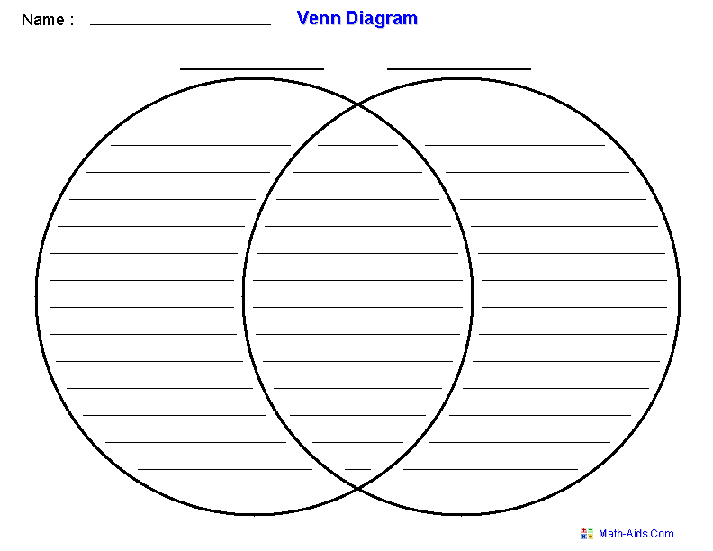
Closure: I’ve enjoyed our time together and I’m already looking forward to next week! You did an amazing job today. (Please give specific feedback at this point.) Possible feedback starters: I liked the way you_________. or I was impressed when you___________. What comments or questions do you have for me? Answer the questions, if you are able and/or willing to do so. End the session with a handshake and the comment, “continue to be a SHINING star today!”

(Scholars should keep all handouts referenced today in their two pocket folder.)
After Session: Before you leave please fill out the Teacher/Mentor Communication Log, check the school calendar for potential conflicting and upcoming events, check your personal calendar to make sure you will be able to return when you told the scholar you would, as the scholar will be looking forward to seeing you, and share any questions or concerns with a school employee—teacher, counselor, principal, etc.—before leaving the building. Thank you for sharing your time and talent!

