The central idea is often referred to as the main idea.

- The central idea is the most important idea in a paragraph or passage.

- All of the other information in the paragraph or passage supports or explains this central idea. The supporting information is called the supporting details.

The graphic organizer shows one way to record the central idea and the supporting details.
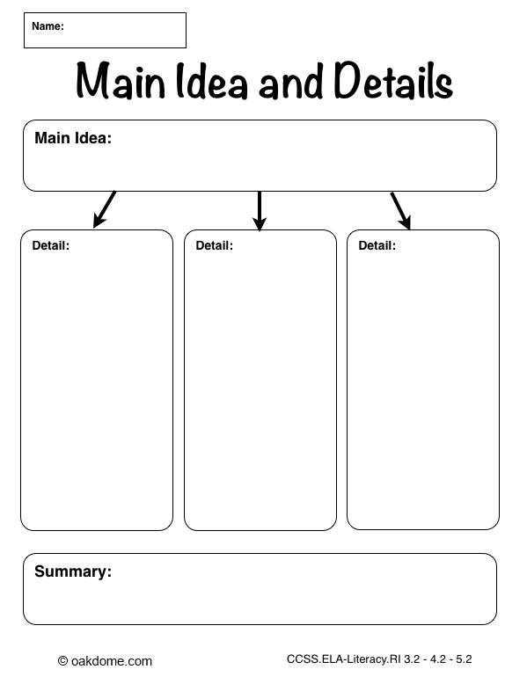
Practice Passage:
Advertising affects our lives everyday. Brand names are common household words. We start each day using the toothpaste, soap, and breakfast foods promoted by advertisers. Ads have made the cars we drive signs of our success. Our choices of food, dress, and entertainment are swayed by ads. Not one aspect of American life is untouched by advertising.

