Focus: Getting the Point!!!
Central Ideas/Main Ideas and Supporting Details

Materials: copies of student notes, graphic organizer, and passages, highlighters, pen/pencil, glue stick

Before Reading:
- Cut the student notes apart from the graphic organizer. Have scholars glue a copy of the student notes in their journal. Take turns reading the notes together. Have scholars highlight the key terms.

Student Notes:
The central idea is often referred to as the main idea.

- The central idea is the most important idea in a paragraph or passage.

- All of the other information in the paragraph or passage supports or explains this central idea. The supporting information is called the supporting details.

- The graphic organizer shows one way to record the central idea and the supporting details.

- After discussing the notes, have students glue the sample graphic organizer in their journal.
Say to scholars: As we read the practice passage, we will record the central idea and the supporting details in this graphic organizer. It is often called a main idea chart. Remember, that a main idea is the same as a central idea.

Sample Graphic Organizer:
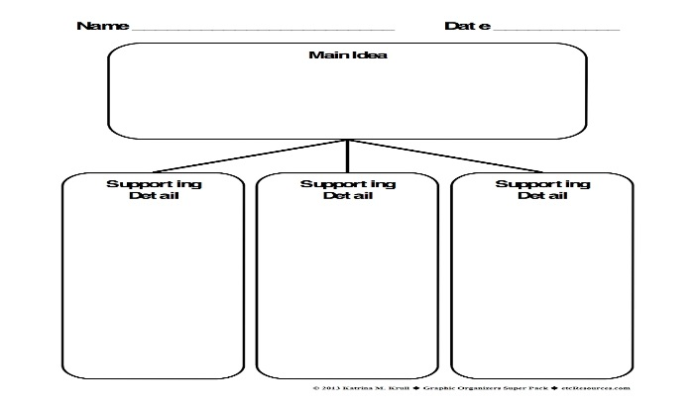

During Reading:
Say to scholars: Glue the practice passage into your journal. Let’s read the practice passage together.

Advertising affects our lives every day. Brand names are common household words. We start each day using the toothpaste, soap, and breakfast foods promoted by advertisers. Ads have made the cars we drive signs of our success. Our choices of food, dress, and entertainment are swayed by ads. Not one aspect of American life is untouched by advertising.

Say to scholars: Look at the guiding questions from your student notes. Let’s find the answers to the guiding questions.

Ask these questions to help you find the central idea.
- Who or what is the paragraph or passage about? (What is the topic?)
- What idea about the ‘who’ or ‘what’ is the author concerned with? (What is the author trying to tell you about this topic?)
- What is the overall point or argument being made by the author about the topic of this paragraph?

Say to scholars:
- Highlight the central idea green and write Central Idea in the margin.
- Highlight the supporting details (SD) in yellow. Label SD in the margin.
- Now write the information in the corresponding sections of your graphic organizer.

*Several passages are included in the resources as time allows for additional practice.

After Reading:
- What is the most important thing to know about central ideas?
- What questions should we ask ourselves when we read informational texts?

Wrapping Up:
- Complete North Star forms.
- Gather and store materials.
- Read lesson #8 for the next session.

